**Installing VMware on Windows(if not present)**

**Step 1:** Click on the link provided below. Now select the version you want to download and click on “Go to downloads”. [*https://customerconnect.vmware.com/en/downloads/*](https://customerconnect.vmware.com/en/downloads/info/slug/desktop_end_user_computing/vmware_workstation_player/17_0)

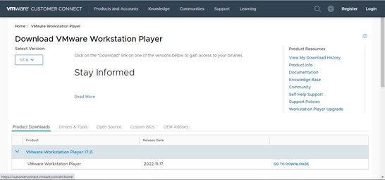

**Step 2:** Now, Click on download now.

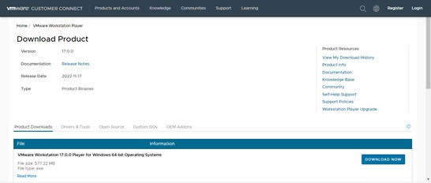

**Step 3:** Open the (.exe) file and install it.

**Step 4:** Open the link below and download the Ubuntu ISO file.

[*https://ubuntu.com/download/desktop*](https://ubuntu.com/download/desktop)

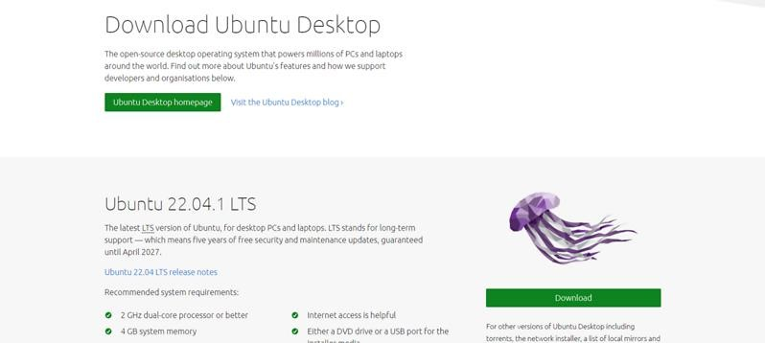

# Installing Ubuntu in VMWare

**Step 5:** Open the installed VMware application.

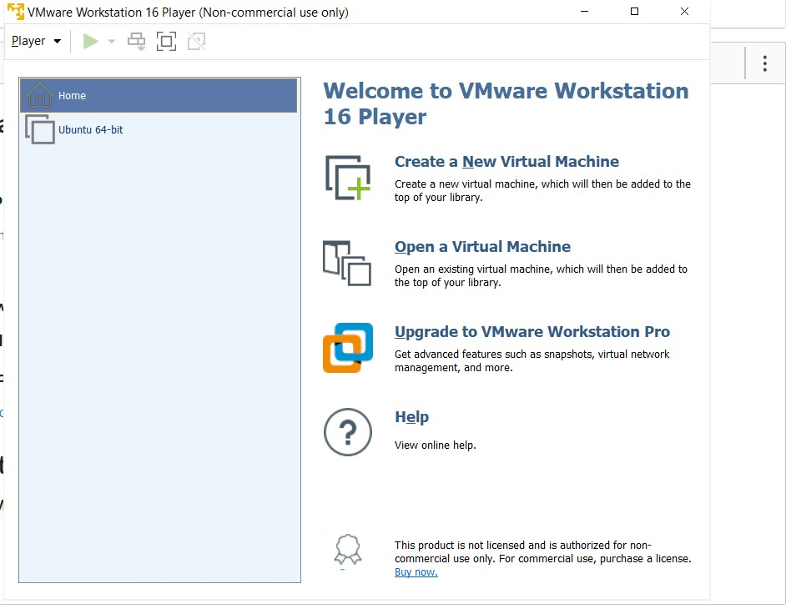

**Step 6:** Click on “Create new virtual machine”. Browse the ISO file that has been downloaded and select it.

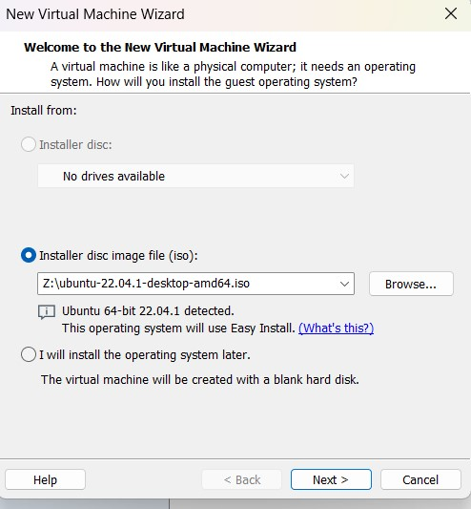

**Step 7:** Enter all the details >> click on next. Personalization of Virtual Machine.

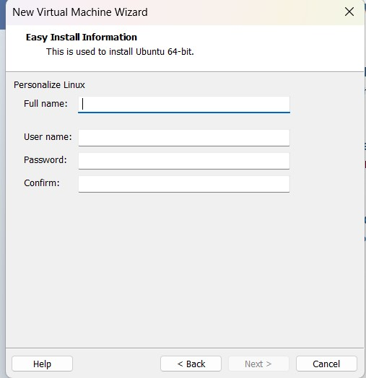

**Step 8:** Enter Virtual machine name >> click on next.

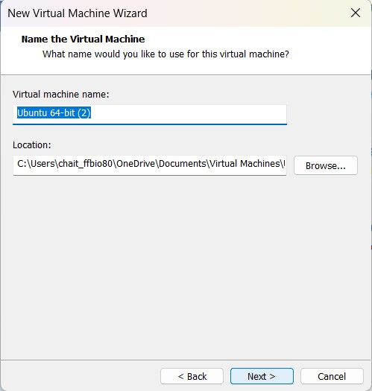

**Step 9:** Specify disk capacity >> click on next.

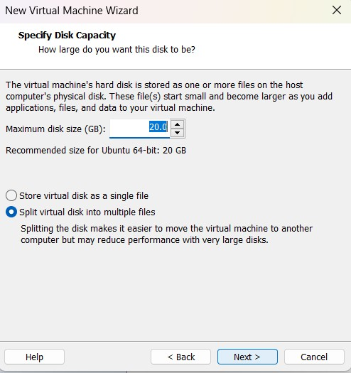

**Step 10:** If needed customize the hardware and click on finish.

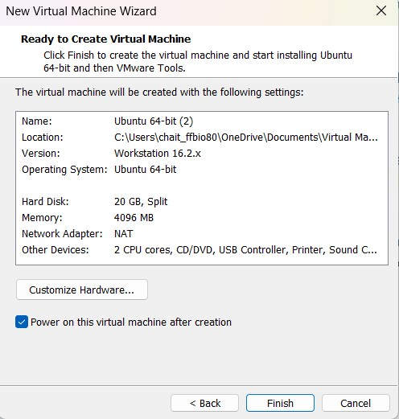

**Step 11:** Ubuntu has been successfully installed in VMWare. Now open VMware and click on ubuntu-64 which appears on the left panel. (If not directly opened). Select the language and click on next. Select the Normal or Minimal installation based on your requirements.

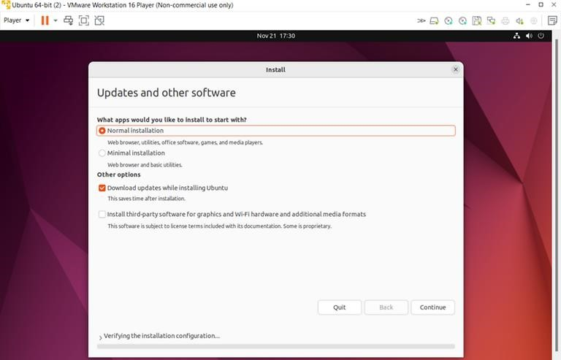

**Step 12:** Select Installation type >> Erase disk and install Ubuntu (This will not delete your windows data) >> Click on install now.

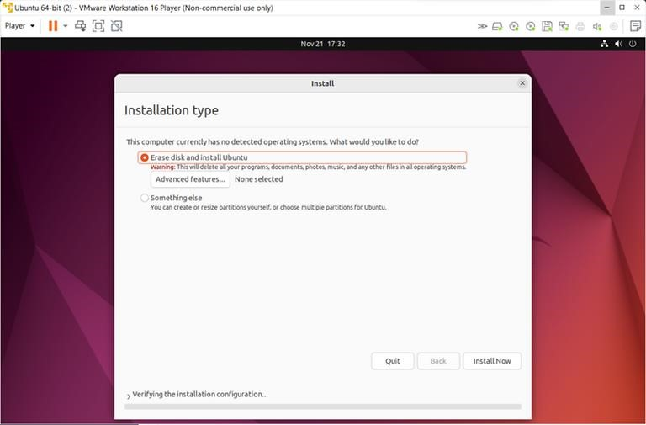

# Installing Windows in VMWare

**Step 13**

**Similarly for windows just install windows 7 in place of Ubuntu (repeat steps from 5th step)**